Table 1: Summarized model outputs for all models. Gray boxes represent the ‘joint_tests’ model outputs which signify which terms and interactions are influential in predicting parasite abundance, while white boxes represent the direct outputs of the ‘glmmTMB’ models indicating specific estimated effects of each term and interaction on parasite abundance. Bolded values are significant and bolded model term items indicate significance at both 3-and 6-month timeframes.

 |  | 3 month |  |  |  |  | 6 month
response variable | model term | estimate | chi2 | F. ratio | p value |  | estimate | chi2 | F. ratio | p value
direct or complex life cycle | event*timing*transmission_strategy | NA | 5.7050 | 5.7050 | 0.0169 |  | NA | 3.4520 | 3.4520 | 0.0632
 | hurricane*post*direct | 0.1988 | NA | NA | 0.0169 |  | 0.3853 | NA | NA | 0.0632
 | hurricane*post*complex | 5.0303 | NA | NA | 0.0169 |  | 2.5956 | NA | NA | 0.0632
monogenean, trematode adult, trematode metacercaria | event*timing*parasite_taxonomic_group | NA | 6.6260 | 3.3130 | 0.0364 |  | NA | 4.5580 | 2.2790 | 0.1024
 | hurricane*post*monogenean | 0.0956 | NA | NA | 0.0186 |  | 0.2159 | NA | NA | 0.0449
 | hurricane*post*trematode_metacercaria | 10.4622 | NA | NA | 0.0186 |  | 5.2435 | NA | NA | 0.0503
 | hurricane*post*trematode_adult | 4.4669 | NA | NA | 0.0660 |  | 2.1532 | NA | NA | 0.1609
myxozoan | hurricane*post | 0.9773 | NA | NA | 0.9851 |  | 0.6187 | NA | NA | 0.5473

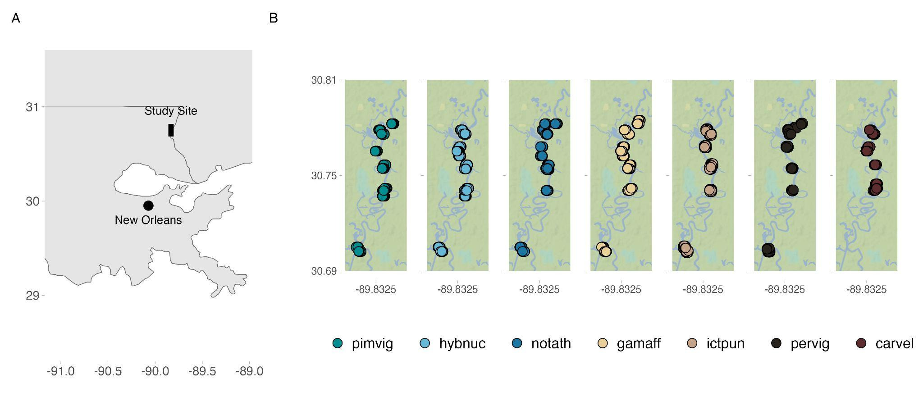
Figure 1. The sampling locations from which fish were originally collected are along the Pearl River in southern Louisiana, about 100 miles north of New Orleans, LA. Latitude and longitude are represented on the y and x axes respectively. (A) Location of Pearl River study site in relation to New Orleans, Louisiana and greater United States Gulf Region. (B) Collection location along the Pearl River for all lots of fish separated out by fish species with points jittered to show overlapping sampling sites (pimvig = Pimephales vigilax, hybnuc = Hybognathus nuchalis, notath = Notropis atherinoides, gamaff = Gambusia affinis, ictpun = Ictalurus punctatus, pervig = Percina vigil, and carvel = Carpiodes velifer).

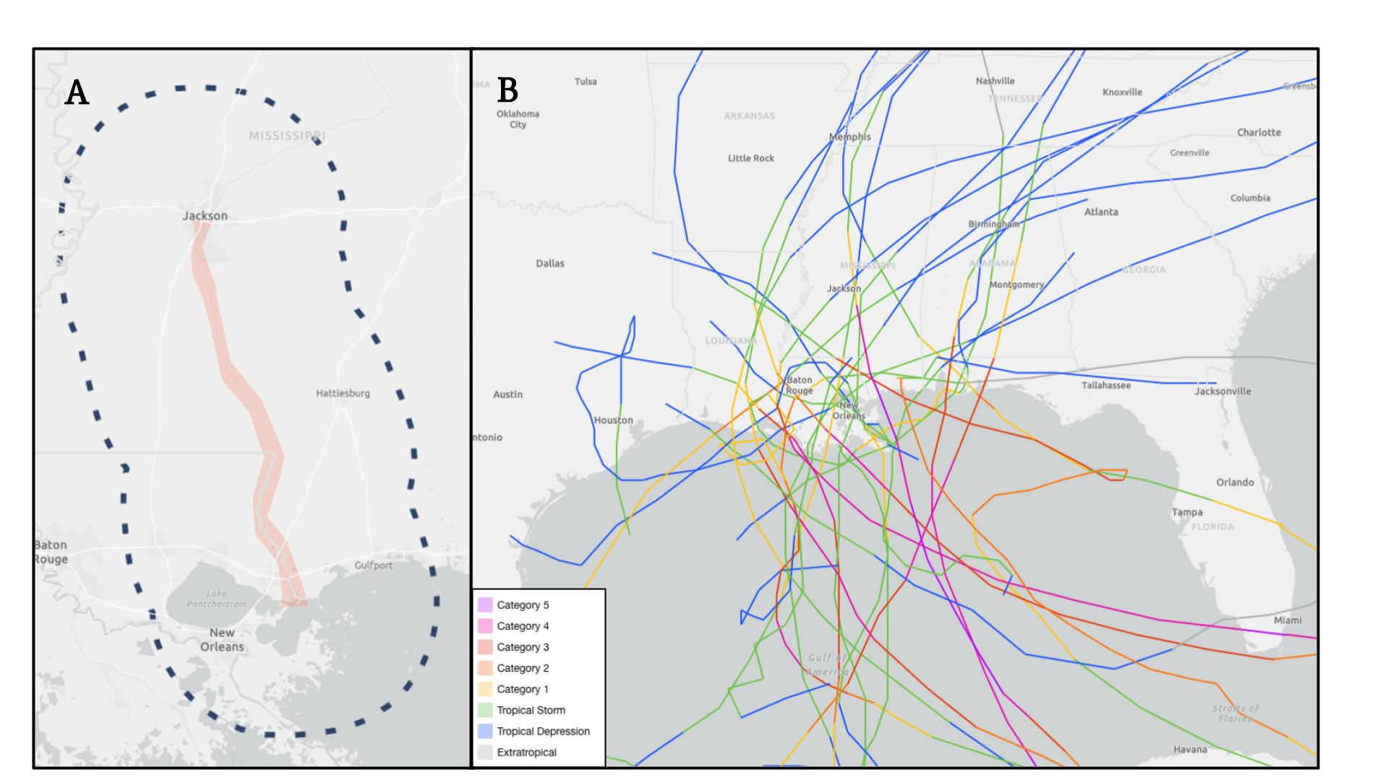
Figure 2. All hurricanes crossing a 50 mile buffer zone around the Pearl River were identified and collected for analysis. (A) A polygon was drawn around Pearl River from source to sea (in red) with a 50 mile buffer zone (dotted line) surrounding the polygon. (B) All storms crossing this polygon were included in this study (25 storms). Images collected from the NOAA Hurricane Watch website.

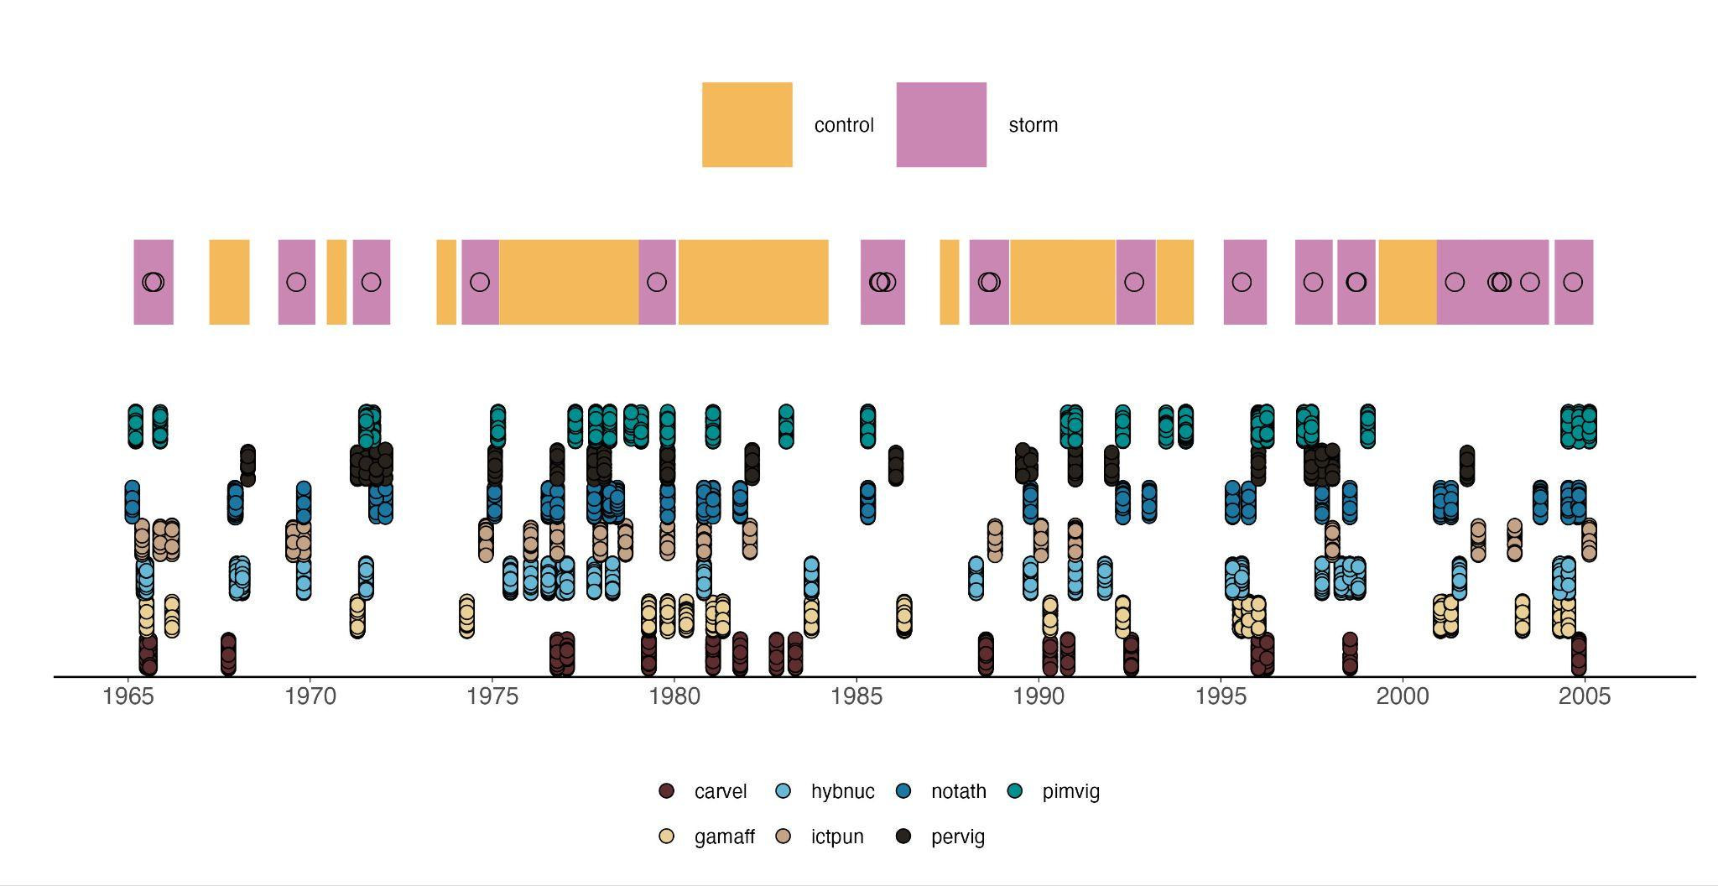
Figure 3. Timeline of hurricane and control events (top) with corresponding fish collected (bottom). Black circles represent actual periods of hurricane occurrence, with 3- or 6-month buffers applied to either side of that storm event to create ‘before’ and ‘after’ conditions. All rectangles represent hurricane (pink) or control (orange) events and their respective buffer zones, so larger rectangles represent longer stretches of storms or controls across multiple years. Though no circle is present in the control events, the same method was applied to controls – assigning a hurricane event to a control year and creating 3- or 6-month ‘before’ and ‘after’ conditions. pimvig = Pimephales vigilax, hybnuc = Hybognathus nuchalis, notath = Notropis atherinoides, gamaff = Gambusia affinis, ictpun = Ictalurus punctatus, pervig = Percina vigil, and carvel = Carpiodes velifer

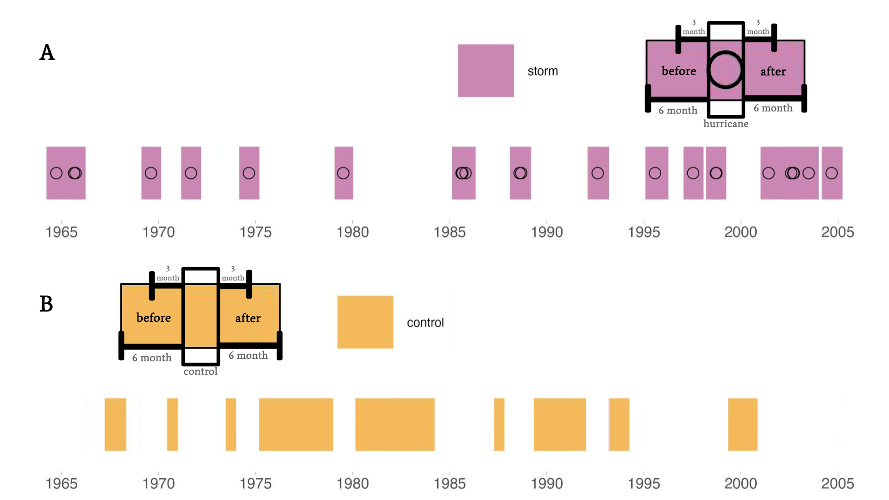
Figure 4. Representation of how control and hurricane ‘before’ and ‘after’ periods were generated. (A) Black circle hurricane events were assigned to non-hurricane (control) years and 3 or 6 month buffers were applied to either end of this event. (B) Control events were generated by applying an actual hurricane event start and end month and day to a year in which a hurricane event did not occur.

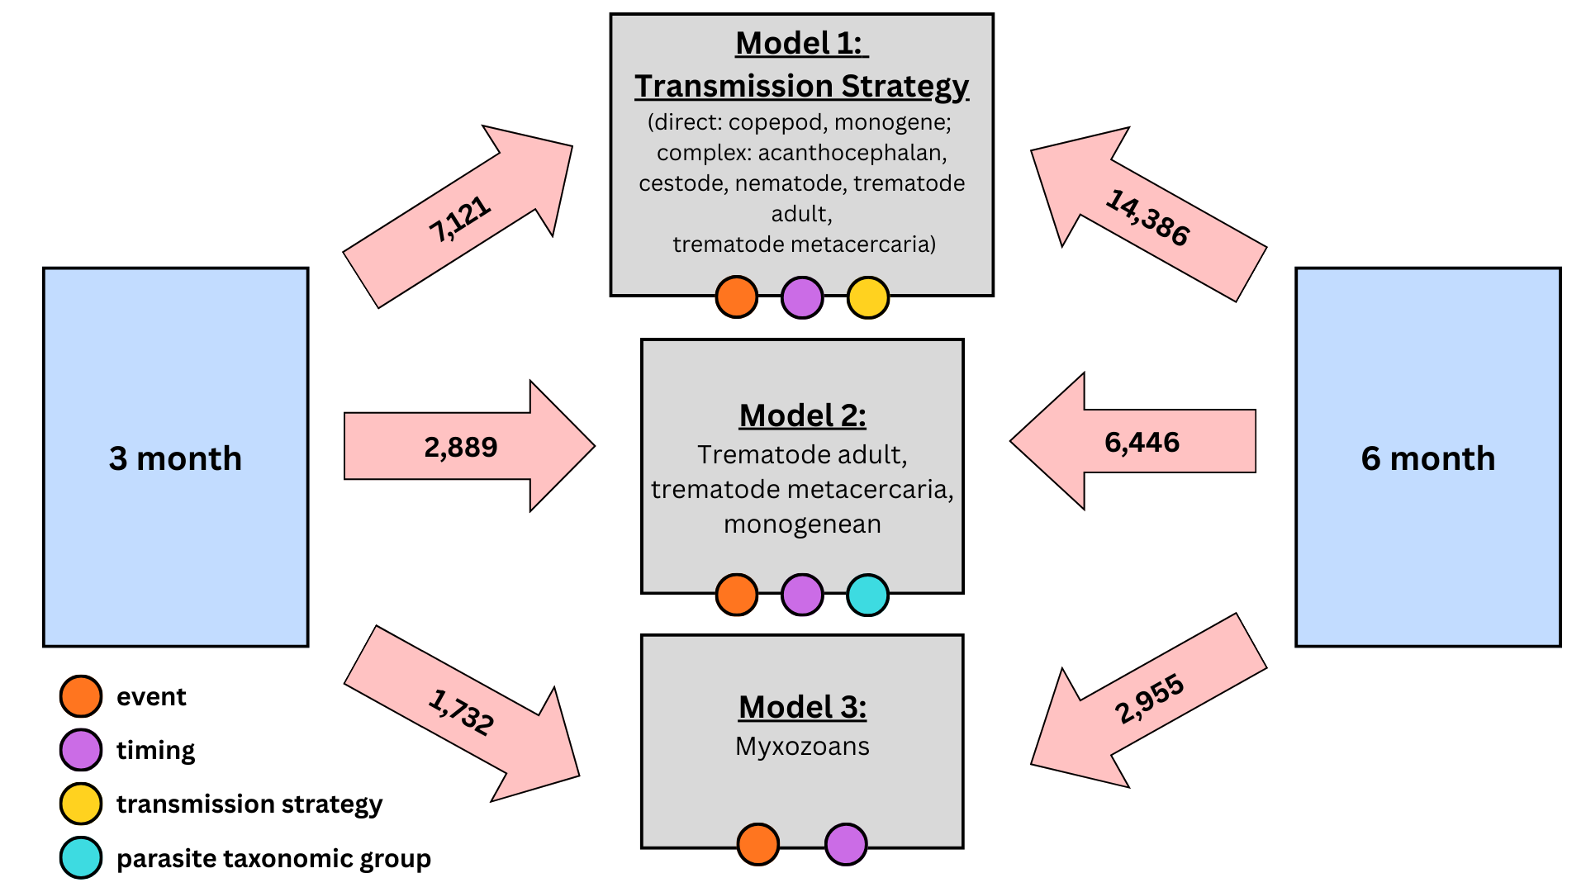
Figure 5. Different combinations of main interaction effects, sample sizes used in each analysis (inside red arrows), analytical subdivisions, and timing of buffer zone on our main three models run. ‘Event’, ‘timing’, and ‘transmission strategy’ consist of two levels each: control and hurricane, before and after, and complex and direct, respectively. ‘Parasite taxonomic group’ consists of three levels: Trematode adult, trematode metacercaria, and monogenean.

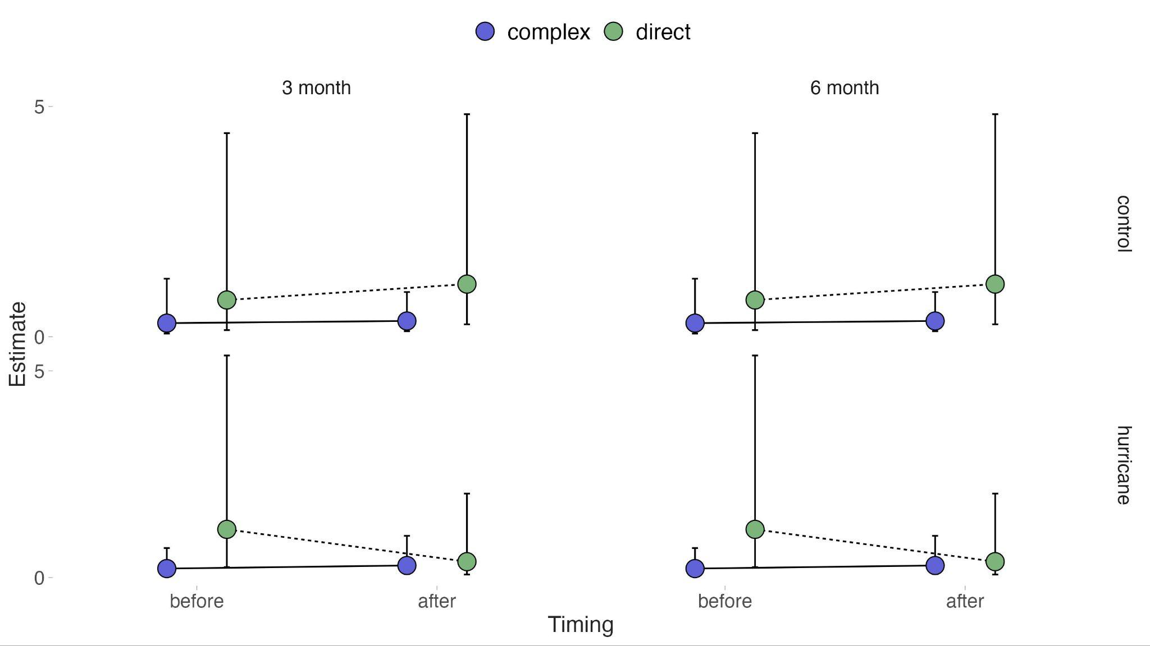
Figure 6. Result of transmission strategy analysis generated from the ‘glmmmTMB’ model and visualized using ‘ggpredict’ where the dots represent the predicted estimate of parasite abundance and the error bars indicate the 95% confidence interval. The y-axis represents the estimated abundance of parasites per fish in each given category between control (top) and hurricane (bottom) events on both pre and post event timescales (as shown on the x axis). Direct life cycle parasite abundance (green) was negatively affected by hurricane presence on short time scales, but this effect diminished on long times scales. Complex life cycle parasites (blue) were not as negatively affected by hurricanes on either time scale.

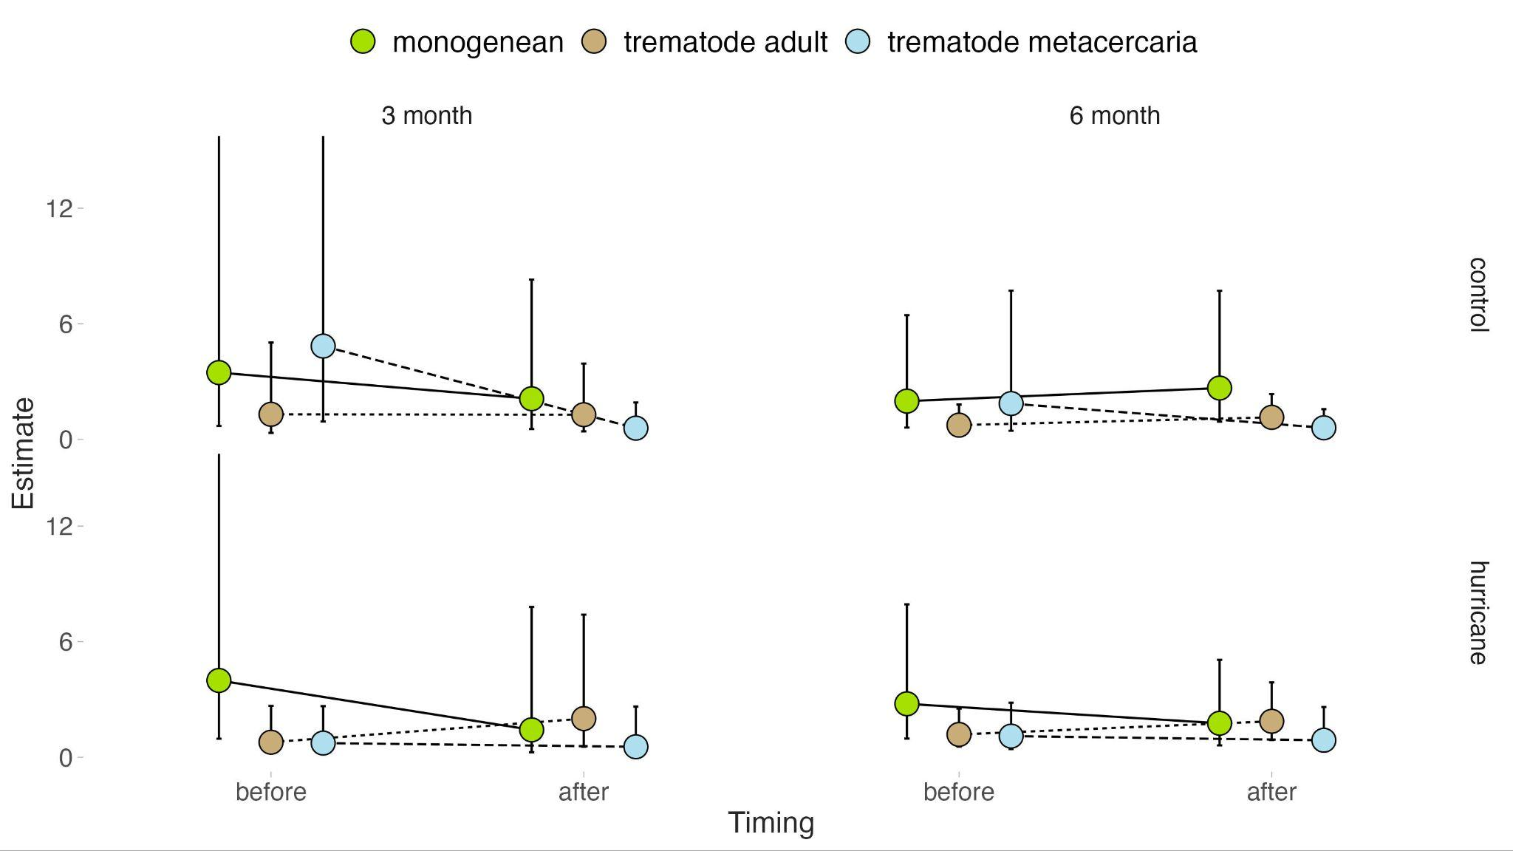
Figure 7. Effects of hurricane events on parasite abundance generated from the ‘glmmmTMB’ model and visualized using ‘ggpredict’ where the dots represent the predicted estimate of parasite abundance per fish and the error bars indicate the 95% confidence interval. The y-axis represents the estimated abundance of parasites in each given category between control and hurricane events on both before and after event timescales (as shown on the x axis). Monogenean parasites declined in abundance following a hurricane on both short- and long-time scales. Trematode metacercaria were not negatively affected by hurricanes, but experienced a decrease in before-event abundance between hurricane and control years. Trematode adults were not affected by hurricanes on either time scale.
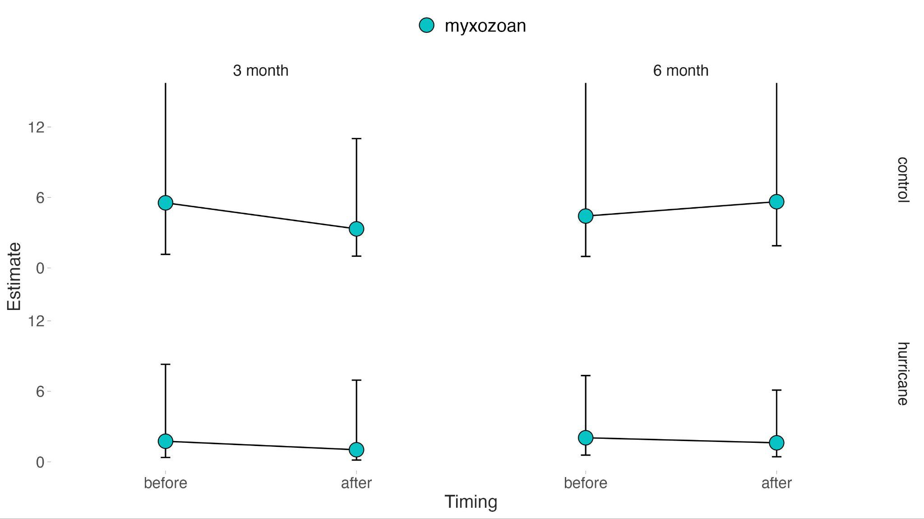
Figure 8. Effects of hurricane events on myxozoan abundance generated from the ‘glmmmTMB’ model and visualized using ‘ggpredict’ where the dots represent the predicted estimate of parasite abundance and the error bars indicate the 95% confidence interval. Myxozoan parasite prevalence was not affected by hurricanes on either time scale as indicated by no significant change in slope of the predicted effect between any sampled condition parameters.

